ONEWAY ACC BY FPS
/STATISTICS DESCRIPTIVES HOMOGENEITY WELCH
/PLOT MEANS
/MISSING ANALYSIS.

Oneway

Notes
Output Created |  | 05-May-2019 23:59:01
Comments
Input | Active Dataset | DataSet0
Input | Filter | <none>
Input | Weight | <none>
Input | Split File | <none>
Input | N of Rows in Working Data File | 30
Missing Value Handling | Definition of Missing | User-defined missing values are treated as missing.
Missing Value Handling | Cases Used | Statistics for each analysis are based on cases with no missing data for any variable in the analysis.
Syntax |  | ONEWAY ACC BY FPS  /STATISTICS DESCRIPTIVES HOMOGENEITY WELCH  /PLOT MEANS  /MISSING ANALYSIS.
Resources | Processor Time | 00 00:00:00.171
Resources | Elapsed Time | 00 00:00:00.179

[DataSet0]

Descriptives
 | N | Mean | Std. Deviation | Std. Error | 95% Confidence Interval for Mean
 |  |  |  |  | Lower Bound | Upper Bound
30 FPS | 13 | 96.8462 | 22.01078 | 6.10469 | 83.5452 | 110.1471
60 FPS | 17 | 93.2941 | 28.62421 | 6.94239 | 78.5769 | 108.0113
Total | 30 | 94.8333 | 25.60722 | 4.67522 | 85.2714 | 104.3952

Descriptives
 | Minimum | Maximum
30 FPS | 63.00 | 128.00
60 FPS | 50.00 | 150.00
Total | 50.00 | 150.00

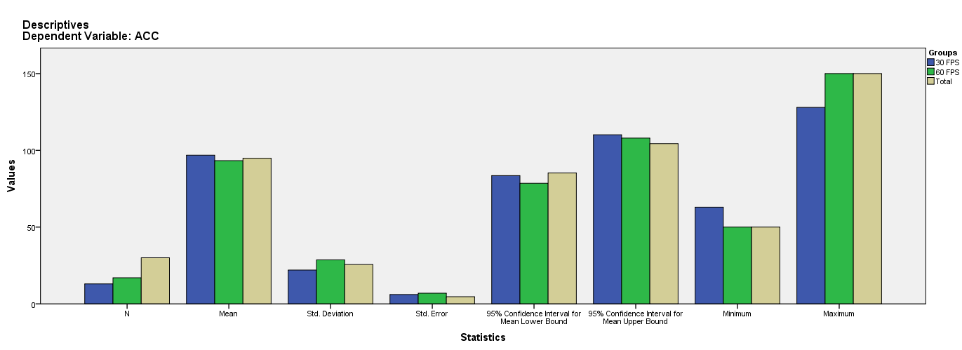

Test of Homogeneity of Variances
ACC
Levene Statistic | df1 | df2 | Sig.
2.255 | 1 | 28 | .144

ANOVA
ACC
 | Sum of Squares | df | Mean Square | F | Sig.
Between Groups | 92.945 | 1 | 92.945 | .138 | .714
Within Groups | 18923.222 | 28 | 675.829
Total | 19016.167 | 29

Robust Tests of Equality of Means
ACC
 | Statisticª | df1 | df2 | Sig.
Welch | .148 | 1 | 27.994 | .704
a. Asymptotically F distributed.

Means Plots

